**TASK 16 OUTPUT:**

1.Opens the browser

2.Window is maximized

3.Navigates to “http://google.com”

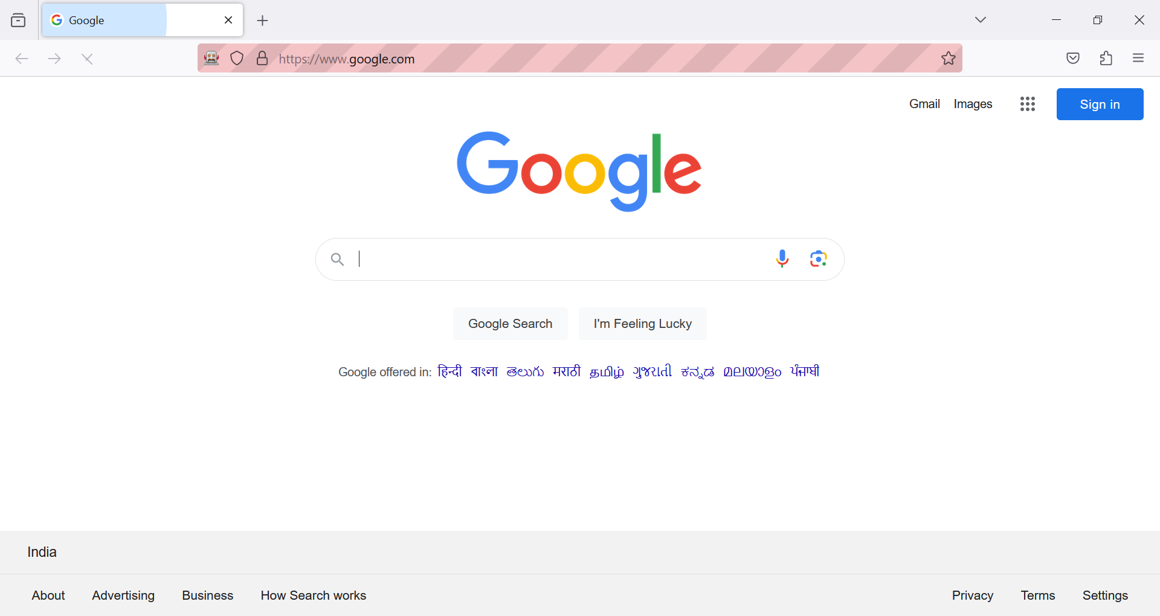

4. Prints the url of the current page

5.Reloads the page and closes the browser

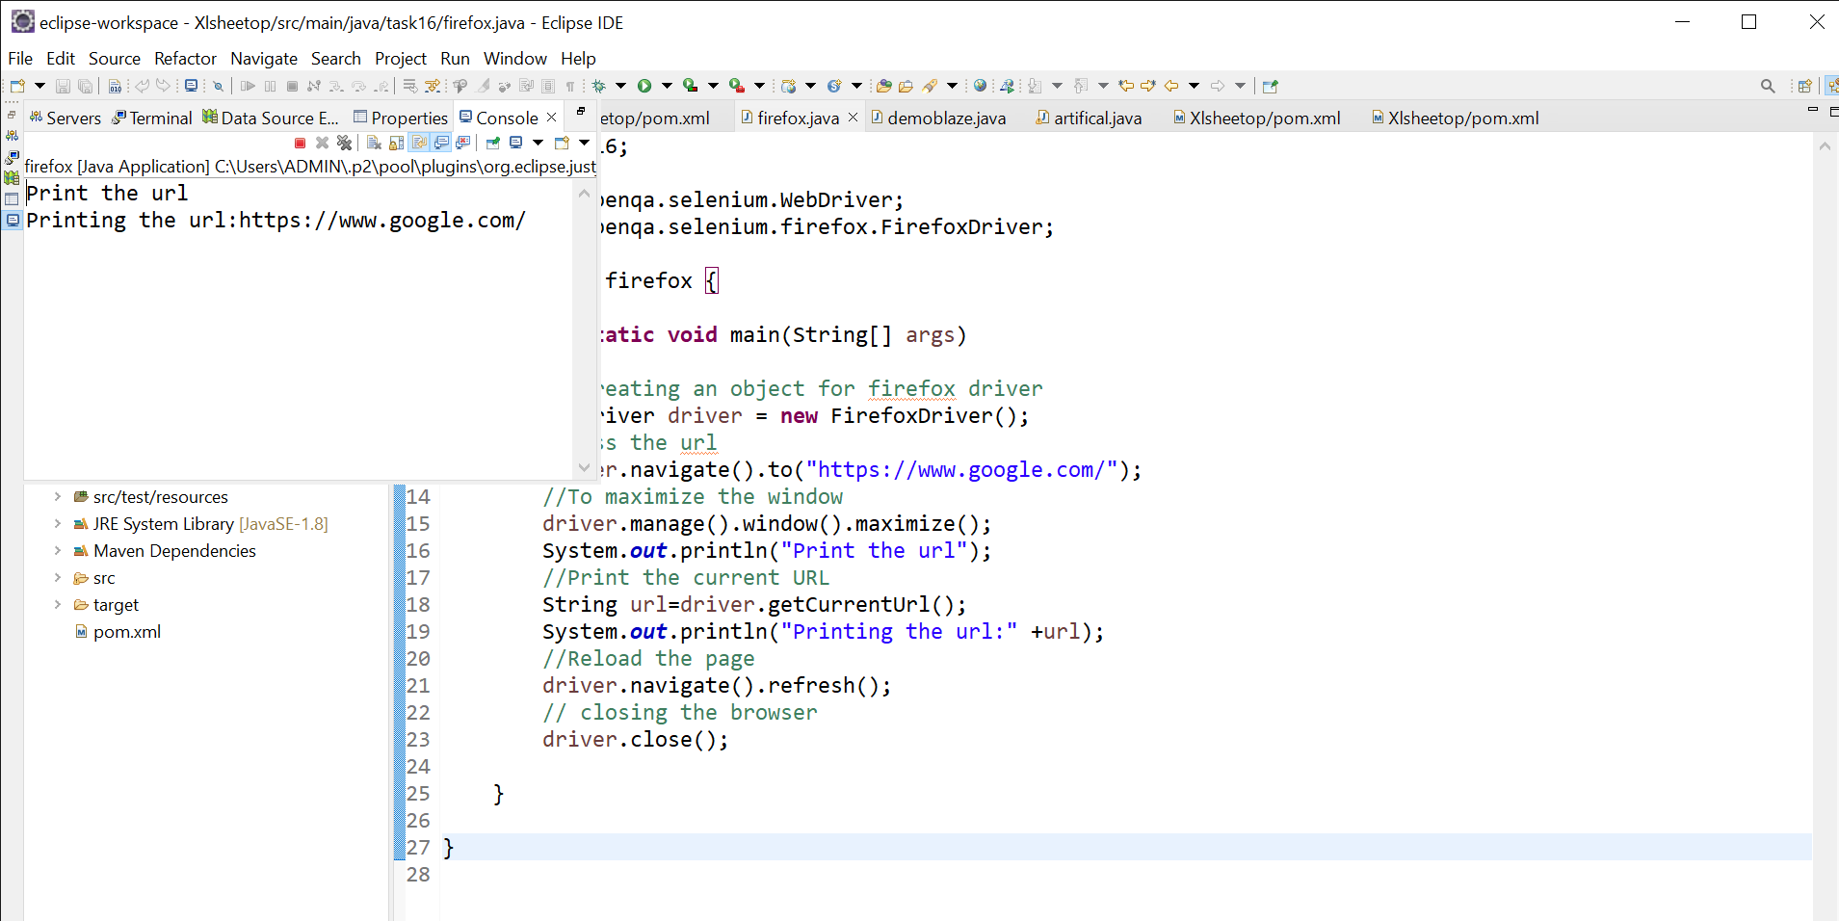

**2.**

1.Opening the chrome browser

2.Navigates to <http://www.demoblaze.com/>

3.Maximised the browser window and verified the title “STORE”.

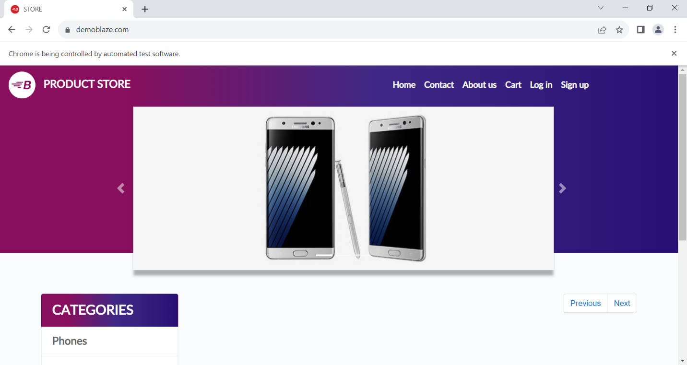

4.Title of the page is STORE and prints the statement.

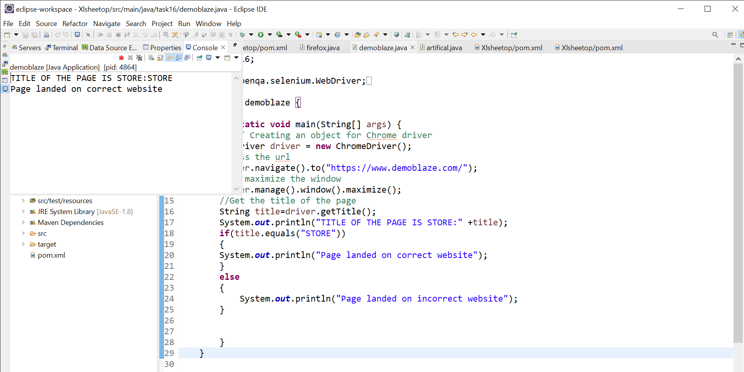

**3.**

1.Chrome Browser is opened

2.Navigated to <https://www.wikipedia.org/>

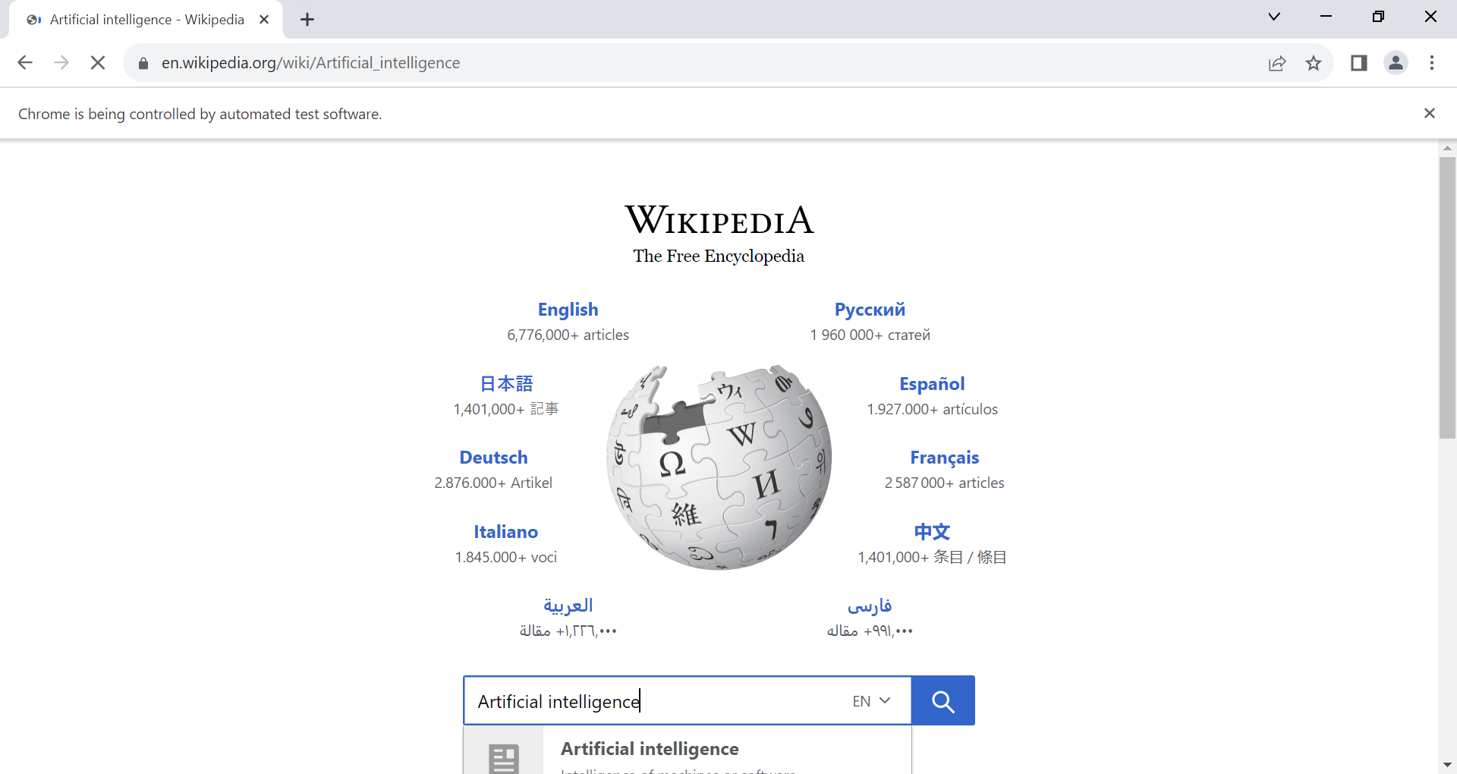

3.Broswer window is maximized and searches for “Artificial Intelligence”

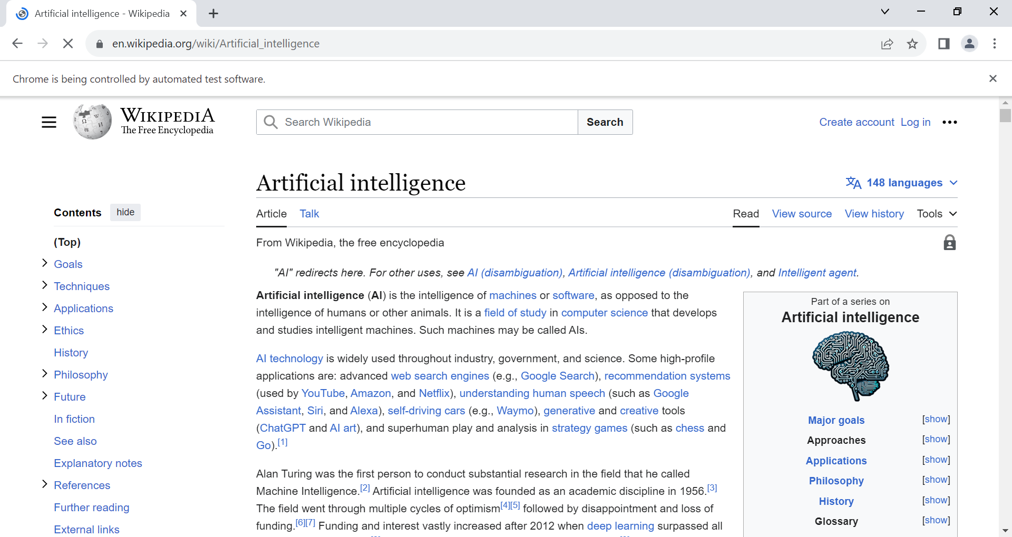

4.Prints the title

